Exp. 2 Design dual led chaser lights

Aim: Design dual led chaser light.

Apparatus: Arduino Board, LED.

Circuit:

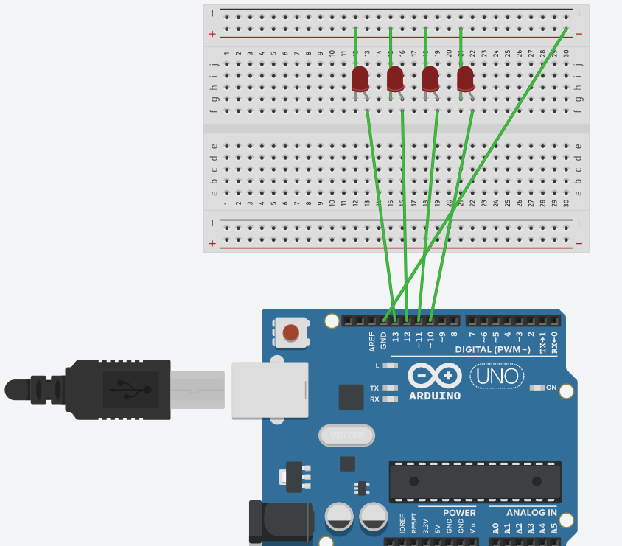Observation:

1.Working of LED chaser.

2.Code for Arduino to Run LED Chaser.

Precautions:

1.There should not be any loose connection in the circuit.

2.Code should be written properly.

3.Arduino should be attached to pc/laptop properly.

Code:

void setup()

{

for (int i = 10; i <= 13; i++)

{

pinMode(i, OUTPUT);

}

}

void loop()

{

for (int i = 10; i <14; i++)

{

digitalRead(allLEDsOﬀ);

if (i!=13)

{

digitalWrite(i,HIGH);

digitalWrite(i+1,HIGH);

delay(200);

}

else

digitalWrite(i,HIGH);

digitalWrite(i-3,HIGH);

delay(200);

digiatlRead(allLEDsOﬀ);

}

}

void allLEDsOﬀ(void)

{

for (int i = 10; i <= 14; i++)

{

digitalWrite(i, LOW);

}

delay(100);

}

Result: chasing of LED was verified after uploading the program.